**Building 3 Report-1222215**

**Determining the number of network outlets in each room**

The number of outlets should be calculated accordingly to the room’s area. According to the structured cabling standards, there should be at least two outlets per 10 $m^{2}$.  
The following table has the final number of needed outlets in each room, according to their area, which is also stated in there.

Before looking at the table there are some important considerations regarding the places that weren´t considered in the measurements:

* Both WC’s and halls were not considered in the calculations since they don’t necessarily need network outlets by default.
* Since rooms 3.0.1, 3.0.2, and 3.0.3 have specific purposes, there are needed two network outlets near each floor cable passageway.
* Rooms 3.0.14 and 3.1.8 are both storage areas and don’t need network outlets.
* A blueprint of a building

  AI-generated content may be incorrect.Room 3.1.1 is a wireless only area, no network outlets are required, but on the other hand the wireless LAN coverage (Wi-Fi) should be highly effective here.

*Image 1 – Floor 0 measurements*

*Image 2 – Floor 1 measurements*



**Network outlets deployment**

Now that we have already determined how many outlets will be in each room, it’s important to define a schematic plan for the deployment of such outlets, pinpointing their locations in the building plan. It is important that, no matter where the user is in the room, there is an outlet less than three meters away, so that was also accounted for when making the plan.

Since the client also requires that the whole building has LAN coverage (Wi-Fi), there were also pinpointed outlets for wireless base stations.

The positions of the outlets were chosen with the primary goal of attending to the three meter rule, then by seeking a better user experience, by having a good placement to their needs, and finnally with the goal of optimizing the use of cable.

*Image 3 – Network outlets deployment schematic plan, floor 0*

To simplify and facilitate, all the outlets were placed on the walls.

*Image 4– Network outlets deployment schematic plan, floor 1*

*Image 4– Network outlets deployment schematic plan, floor 1*

In both floors two Wi-fi outlets were placed. They were all placed strategically to assure that the whole building has full LAN Coverage, floor 0 by having one access point covering each corner. For floor 1, given the special request for room 3.1.1 being a wireless only area and needing higher efficiency LAN coverage (Wi-Fi), an outlet was placed inside the room itself, as to not have any signal be dissipated, potentially, by walls and a second one placed further down to cover the remaining areas.

**Cross-connects and cable pathways deployment**

With the deployment of the outlets out of the way, we can now move on to deciding where each cross-connect will be placed. Since for this we must account for the fact that no outlet can distance more than 80 meters in a straight line from the horizontal cross-connect and that the cable length must be under 90 meters, it’s easier to simultaneously make the cable pathways deployment plan.

**Floor 0**

To better and easier understand the next image, a brief explanation of some key points might be helpful.  
 The goal of this deployment plan was to try to use the less cable possible, while at the same time having a smart distribution of the cables (basically, trying to avoid messy points).   
 As the legend states, the orange lines represent CAT7 cable passageways, which means that where there is one of those, one or multiple CAT7 cables pass through it.  
 Since on this floor there is a pre-built underfloor raceway, whenever it was possible to use it to pass cables from one room to another, it was used.

Another relevant note about these connectors is that they are inside a telecommunications enclosure, and it should be considered that it is closer to the corner than it appears in image 5, making the cable represented longer than it really is.  
 A set of CP’s (Consolidation points) were also added in the plan in particularly high outlets density areas, to reduce the total cable length by having them placed strategically and to reduce the density of cables passing through the passageways. Only the necessary amount of CP’s was used to reduce the number of unused ports. For calculations and actual placement of the cables, they should be connected to the closest CP with available ports, unless in cases like in room 3.0.15, where it’s clear that the better option is to connect the outlets directly to the HC.

To respect the three successive levels of cable distribution, we have in room 3.0.14 an IC (Intermediate cross-connect) that has the responsibility of connecting the “outside world” to the HC’s (Horizontal cross-connects) of the building. To do so, we use monomode 10 cable, which although not visible, is used between the IC and the HC on the same floor, which are very close to each other. Two more monomode 10 cables were used, one that goes through the ceiling passageway to connect to floor 1’s HC and another that goes through the underfloor raceway to connect to the MC.

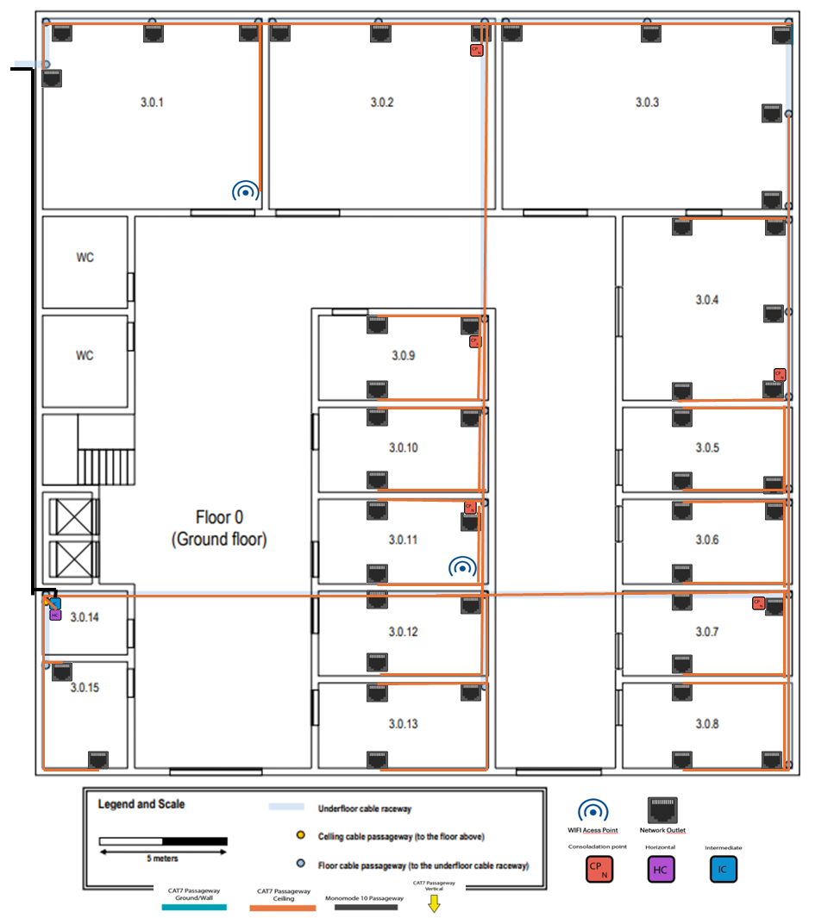

*Image 6 – Cross-connects and cable pathways deployment schematic plan, floor 0*

**Floor 1**

Just like in floor one, there are some decisions and some explanations that will help the understanding of the plan. With that in mind before the image, some more key points will be explored, although in similar points like the use of CP’s, the already given explanations should be accounted for.

One of the main differences is that on the first floor there is no underfloor raceway where we can pass the cables by so that won’t remain the same. We have instead a removable dropped ceiling situated 2.5m from the ground that covers the entire floor and since that space is empty, it’s perfect to install cable raceways. To provide better visualization, the passageways in the ceiling are represented by the orange lines and the passageways in the ground/walls were represented by the blue lines. There are also yellow arrows that indicate where the cables drop from the ceiling. Now that we are on another floor, an HC was placed in room 3.1.8 since that’s where the Monomode 10 cable comes from the ground floor.

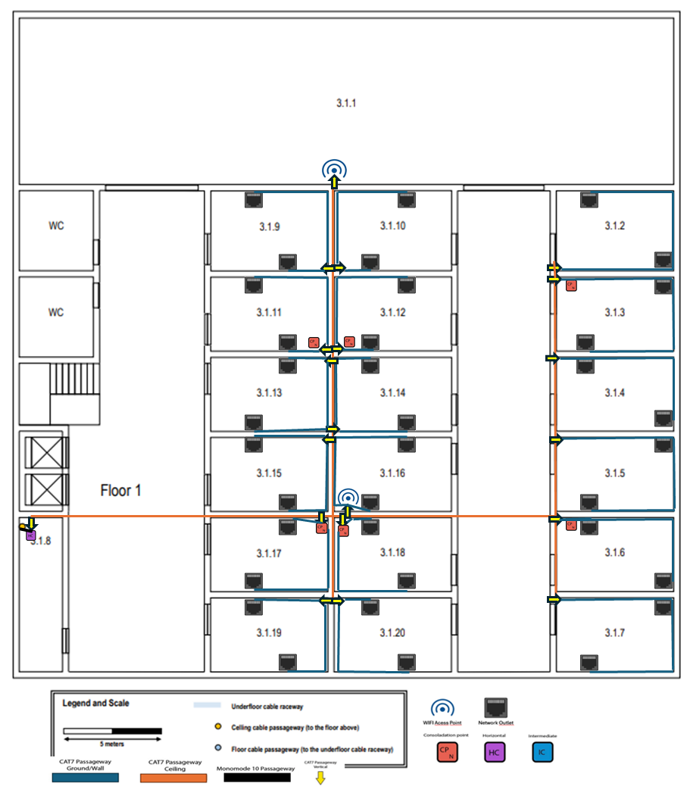**Important note:** All the network outlets should be situated 0.5m from the ground and all the telecommunications enclosures 1.5m from the ground.

*Image 7 – Cross-connects and cable pathways deployment schematic plan, floor 1*

**Hardware inventory**

Before considering the structured cabling project for building 3 as done, it is important to make a final hardware inventory to ensure that all necessary equipment and hardware are available, the project plan is efficient, and documentation is complete.

The inventory was divided by floors to facilitate the analysis of it, and then it was merged to have the final totals.

**Floor 0**

|  |  |
| --- | --- |
| **Item** | **Units Used** |
| **Outlets** | **92** |
| **CAT7 Cables** | **102** |
| **CAT7 Length** | **~1093** |
| **Monomode 10** | **3** |
| **Monomode 10 Length** | **~27** |
| **Access Points** | **2** |
| **IC (Intermediate Cross-Connect)** | **1** |
| **HC (Horizontal Cross-Connect)** | **1** |
| **Consolidation Points** | **5** |

,

**Floor 1**

|  |  |
| --- | --- |
| **Item** | **Units Used** |
| **Outlets** | **72** |
| **CAT7 Cables** | **86** |
| **CAT7 Length** | **~916** |
| **Monomode 10** | **1** |
| **Monomode 10 Length** | **~2** |
| **Access Points** | **2** |
| **IC (Intermediate Cross-Connect)** | **0** |
| **HC (Horizontal Cross-Connect)** | **1** |
| **Consolidation Points** | **6** |

**Total Inventory**

|  |  |
| --- | --- |
| **Item** | **Units Used** |
| **Outlets** | **164** |
| **CAT7 Cables** | **188** |
| **CAT7 Length** | **~2009** |
| **Monomode 10** | **3** |
| **Monomode 10 Length** | **~29** |
| **Access Points** | **4** |
| **IC (Intermediate Cross-Connect)** | **1** |
| **HC (Horizontal Cross-Connect)** | **2** |
| **Consolidation Points** | **11** |